**Operating System Lab**

**CS342**

Tanishq Malu Midsem 1901CS63

Q1

Compilation:

gcc question1.c

Syntax:

./a.out

checkLine.c – the program whose lines are counted and printed in different txt files.

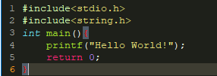

Sample Input and Output:

Input:

gcc question1.c

./a.out

Output:

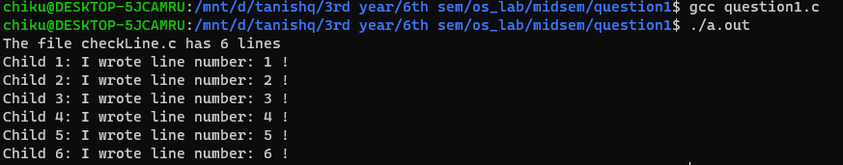

Q 2.

here are two files "parent.c" and "child.c" for this questionCompilation:

gcc -o parent parent.c

gcc -o child child.c

Syntax:

./parent girl nancy boy mark boy joseph

Sample Input and Output:

Input:

./parent girl nancy boy mark boy joseph

Output:

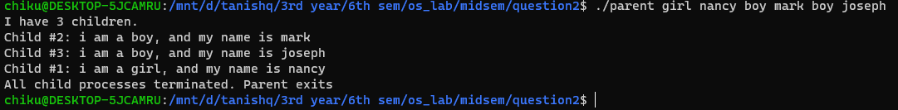

Q3.

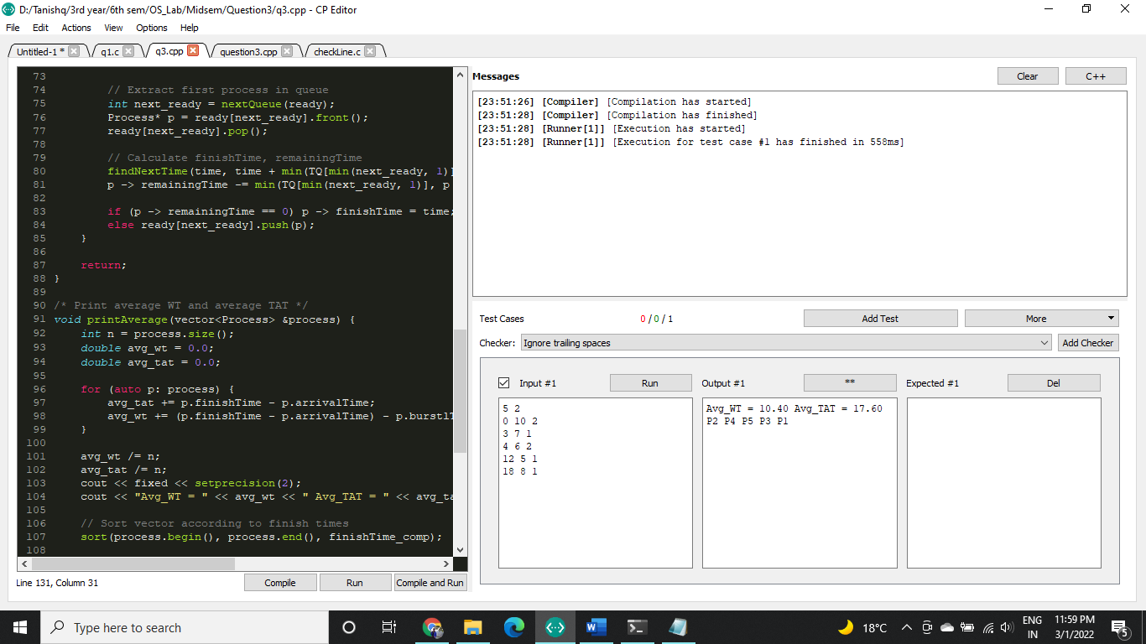

Q4.

gcc -o q4 q4.c -lpthread

./q4

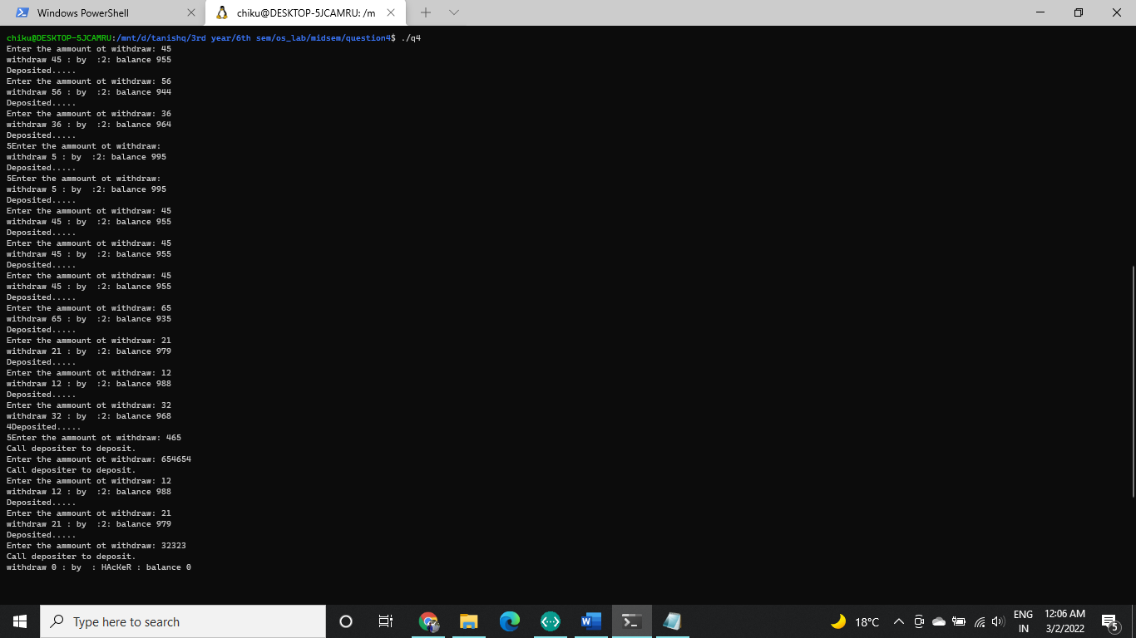

As you can see, the program terminates, once hacker hacks treasure before the borrower.

-------------------------------------------------- The End -----------------------------------------------